Who Pops the Most: A Game for Toddlers

1. Collect about twenty balloons, fill them with water.
2. Assemble them in two sides of a swimming pool, or a large tub (You may hang a rope to mark different sides).
3. Now, divide the players into two teams and let them stand in their respective zones.
4. As you blow a whistle, they will start stomping the balloons. The team that pops the highest number wins.

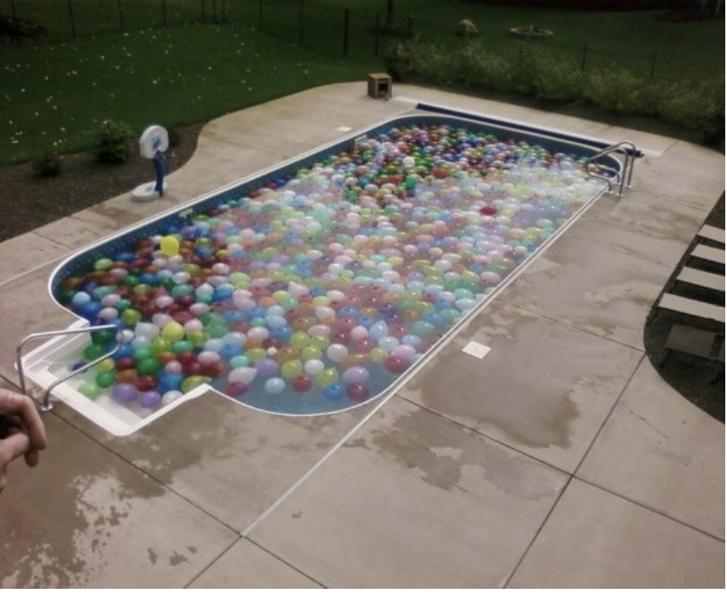

Catch and Find: A Fun Game for Kids of All Ages

It is better to play this game outdoors, like in the park or your backyard, as it is sure to get messy.

1. Put small items like marbles, pennies, or balls along with water into the water balloons.
2. Make two teams and give each, an empty container.
3. As each team throws balloons at their opponent, they have to catch and gather the stuff inside.
4. Set a time limit. The team with the greatest number of objects will be the winner.

Who’s the Driest: A Classic Water Balloon Toss Game

1. Make two groups and give the same number of water balloons to each.
2. Mark specific territories for the two teams with cardboard boxes. (Placing a large table between them would work as well)
3. As soon as you say “start,” they will start drenching each other by throwing the balloons. Whichever team is the driest after all the balloons are gone, dons the winning cap.

Water Balloon Pinata: An Individual Challenge Game for Parties

A good option for smaller groups, it’s a fun one for adults as well as kids.

1. Hang several water balloons in a string.
2. Blindfold each child in turn with a bandana.
3. Then allow them to burst three balloons within three chances. The child who can successfully do so is the champion.

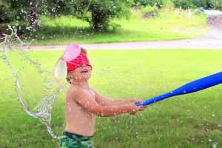

Swinging the Bucket: A Colored Water Balloon Fight for Teenagers

This one is more fun to play at the beach, but your backyard is also a good option.

1. Add a few drops of food color of your choice to the water while filling the balloons. (Using different colors is more fun)
2. Fill a small bucket up to the brim with the colored balloons.
3. Tie the bucket to a long rope.
4. Then, dangle it in a way that one player will have to stand under it, firmly holding one side of the rope so as not to spill the bucket on his/her oChildren get easily bored and drained out in the lazy, long days of summer. Make these dull days exciting by arranging any of these water balloon games. You may add your variations too.wn head.
5. Make the other kids throw water balloons at the player standing under the bucket for 1 minute (use a stopwatch)
6. The moment the first player loses grip on the rope, he/she will get smeared by the colored balloons. One who withstands till the end emerges victorious

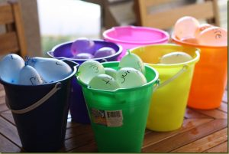

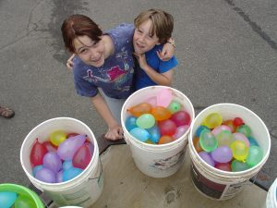

**Redlight, Greenlight**



Similar to the statue game, redlight and greenlight can be enjoyed by everyone.

**How To Play:**

* Select one player to be the traffic light or traffic cop.
* All the other players have to scatter around.
* When the traffic light says ‘redlight’, players must freeze and stay still.
* And when the traffic light says ’greenlight’, players must start moving, running and jumping around.
* Any player who fails to follow the instructions of the traffic light is eliminated.

**Wheelbarrow Race**

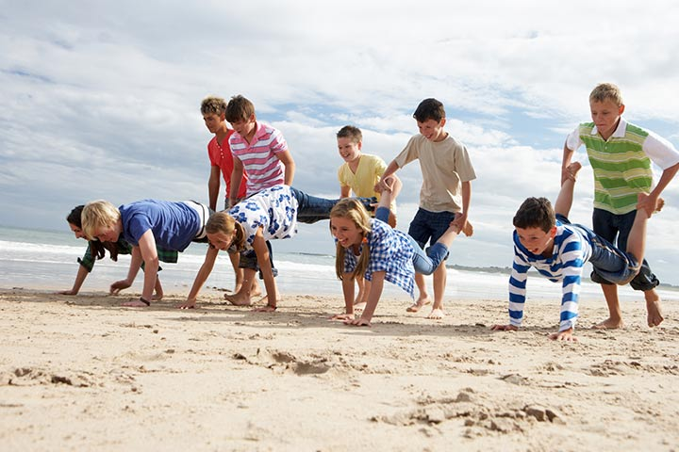

**One of the very popular outdoor picnic games for children is the wheelbarrow race.** So find a smooth and comfortable place to play this game.

**How To Play:**

* Divide the players into teams of two.
* One among the two is the driver and the other is a wheelbarrow.
* Set a start and finish line.
* The driver holds the ankles of the wheelbarrow, and the player who is the wheelbarrow walks on their hands.
* The team which reaches the finish line first wins.

**I Spy**

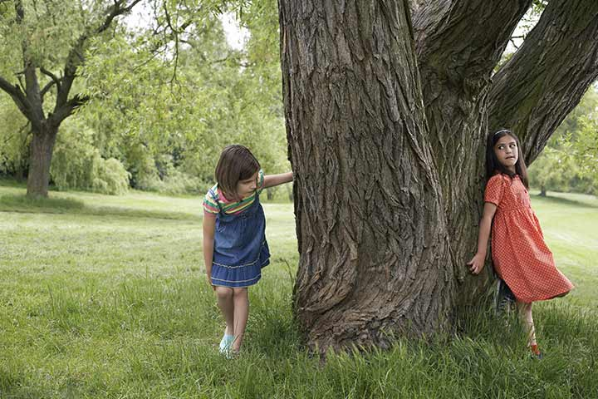

Games like hide and seek can be enjoyed by [kids of all ages](https://www.momjunction.com/articles/computer-games-for-kids_00778104/) and grown-ups too. **The best part of this picnic game is that you need no supplies.**

**How To Play:**

* Choose one player to be the spy, who has to count till 10 while keeping the eyes closed.
* Every other player has to find a spot to hide before the spy finishes counting.
* Spy has to scout the entire location and find each hiding player.

**Big Fish - Little Fish**

Number of players: Requires 1 game master and as many participants as possible.

Location/terrain: The game needs to be played outdoors because it requires a large number of players and is best played in an open field or a spacious area.

How to play: Members of the team form a circle. When the game master shouts "Big fish," they stretch out their arms, and when they shout "little fish," they pull their arms back. During the game, the game master does not follow any rules. If any player fails to respond correctly, they will be eliminated or penalized according to the game master's discretion.

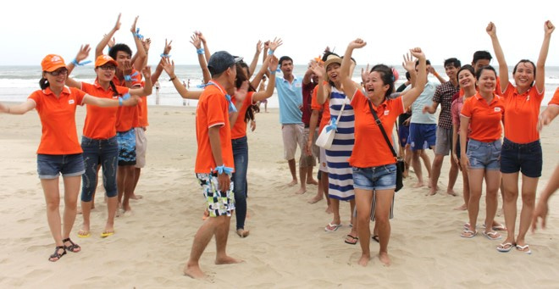

**Cluster Formation**

Number of players: Requires at least 2 teams, with each team consisting of 3 players.

Location/terrain: Outdoor team building game Cluster Formation is played in a wide playground or open field.

How to play: Members will form a circle together. When the game master shouts "Cluster, cluster," players respond with "How many, how many." When the game master shouts "Cluster 5 members in one group," players quickly form groups of 5 people as fast as possible. Members who fail to form a cluster with any group will be caught and participate in penalty games. The number of people in each group will vary, with groups consisting of 3, 5, 7, or 10 people depending on the game master's decision.

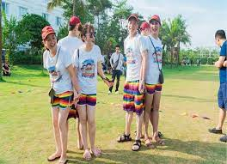

**King Hung's Demand**

Number of players: It is recommended to have more than 2 teams, with each team having more than 2 players.

Location/terrain: This team-oriented game requires ample space, so it is best played outdoors.

How to play: Teams gather at the playing area. The fastest member from each team steps onto the stage. When given the signal by the game master, they shout: "King Hung's need, King Hung's need".... Players respond with: "What's needed, what's needed?"

The game master presents various items available at the team building venue. Team members need to quickly choose and rush to retrieve the items located under their team's position, aiming to retrieve them as fast as possible. The team that retrieves the items the quickest, most accurately, and in the required quantity will earn the highest score.

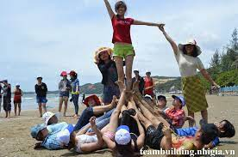

**Brotherhood**

Number of players: Since this is a unity-focused game, each team should ideally consist of at least 2 players, with a minimum of 2 teams playing. However, for more enjoyment and team bonding, it's advisable to have more players on each team.

Location/terrain: Best played outdoors in a spacious field.

How to play: Team members stand in a circle or in a straight line, with players standing next to each other and linking arms over each other's shoulders. When the game master gives the signal, players respond and perform the following actions:

- Game master: "Unity"

- Players: "Unity" and jump to the left by one step.

- Game master: "Link"

- Players: "Link" and jump to the right by one step.

- Game master: "Brother"

- Players: "Brother" and take one step backward.

- Game master: "Sister"

- Players: "Sister" and take one step backward.

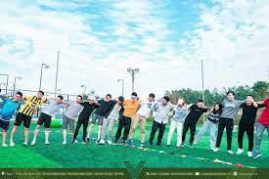

**Group Massage**

Number of players: For this outdoor team building activity, all members of the team need to participate to enhance teamwork, with a minimum of 2 players returning.

Location/terrain: The game should be played outdoors in a cool and breezy environment.

How to play: Team members form a circle and stand in a line behind one another, placing their hands on the shoulders of the person in front of them. The game master gives commands for all members to perform actions such as massaging each other's shoulders and gently tapping each other's backs.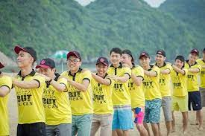

**Directional Message**

Number of players: This game requires 6 players per team, each holding a pen, and there should be at least 2 teams to write the directional message.

Location/terrain: It can be played outdoors or indoors with ample space.

How to play: Each member of the team holds one end of the pen, and together they write a goal set by the team through discussion. After the first team finishes writing a goal, it moves on to the second team, and the process continues. Within a time limit of 10 minutes or as determined by the game master, the team that writes the most meaningful and significant goals will win.

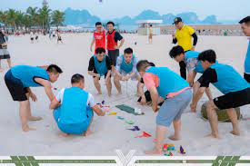

**Fueling Passion**

Number of players: The game requires 2 teams, with each team consisting of 6 members wearing a well-tied rope.

Location/terrain: With a game requiring many players like this, teams also need a spacious area, particularly outdoors.

How to play: Each time the teams move, 6 members in each team wear the rope skillfully around their waist, draping it over the shoulders of their teammates to form a circle. When given the signal by the game master, teammates begin and combine to run from the starting line to the finish line.

Here, one person carries one item back to the starting line. There are two ways to carry the items: either hold it in hand or place it on a plate skillfully positioned next to the flame of passion. While playing, if a player's hand leaves their teammate's shoulder or the item falls into the flame of passion, it will be considered a fault and deduct 30 points per fault.

After a specified period, the team that brings back the most items to the finish line will earn the highest score, corresponding to 50 points each.

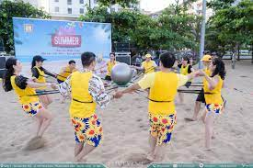

**Breakthrough of Will**

Number of players: More than 2 teams, with each team consisting of 3 players.

Location/terrain: For this game, players need a spacious area as water will be sprayed around the playing area.

Equipment: Since the game requires a tall column with holes, a water bucket, and a small ball, it's best played outdoors.

How to play: Players must hold the water column to keep it upright, with a small ball inside the column. When given the signal by the game master to start, players pour water into the column and use various parts of their bodies to prevent the water from escaping. In the shortest time possible, the team that causes the ball to overflow out of the column the fastest will be the winning team.

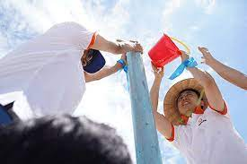

**Tower of Trust**

Number of players: For this outdoor team building game, planning for bridge construction, each team should consist of around 4-5 players.

Location/terrain: With 30 large wooden sticks assigned to each team, playing outdoors is suitable to fully utilize their creative abilities.

How to play: Team members brainstorm together to devise a plan for building an arched bridge based on the principles of support without using adhesive materials. The team that constructs the wooden bridge the fastest wins.

In the event that a team fails to complete their bridge, the organizers or the game master will show them a model, then allow a period of 10 minutes or a specified time for the teams to rebuild their bridges.

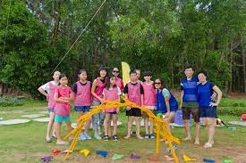

**High-Speed Racing**

Number of players: The game requires multiple teams, with each team consisting of 2 players. Therefore, the number of players in each team must be divisible by 2.

Location/terrain: The game is played in a large field to allow the turtle cars to move efficiently.

How to play: Each pair of male-female participants forms a team and receives a turtle car at the starting position. The female sits on the car while the male pushes it, helping the car navigate through obstacles such as traffic cones to reach the finish line. Once there, they retrieve a flag, return to the starting position, and plant the flag. They then pass the car to the second pair of their team and continue in the same manner. The team that collects 10 flags first and within the shortest time wins.

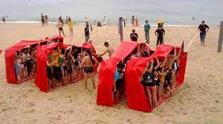

**Battle of the Turtle and Rabbit**

Number of players: Each team consists of 5 members, and there are 2 teams competing.

Location/terrain: The game is played outdoors or in a spacious area.

How to play: Each team has 5 members competing while sitting down. Team members take turns to compete in direct elimination matches, with each match lasting for 10 minutes, and there will be a winning team for each match.

Note: Players are only allowed to move using their buttocks, and the field is filled with a layer of water and safe foam bubbles, with a size of 7m x 15m.

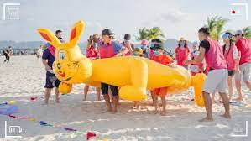

**Endless Effort**

Number of players: Each team consists of 5 members, and there are 2 teams competing.

Location/terrain: The game is played outdoors or in a spacious area.

How to play: Each team has 5 members competing while sitting down. Team members take turns to compete in direct elimination matches, with each match lasting for 10 minutes, and there will be a winning team for each match.

Note: Players are only allowed to move using their buttocks, and the field is filled with a layer of water and safe foam bubbles, with dimensions of 7m x 15m.

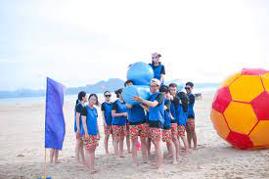

**Reaching Out to the Vast Sea**

Number of players: Each team requires 5 players.

Location/terrain: Played along the coastline.

How to play: Team members link together to form a boat and paddle out to sea. They move towards the designated finish line to retrieve a victory flag. The team that brings back the flag in the shortest time wins.

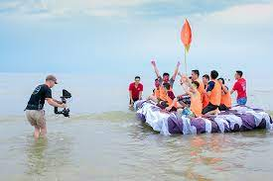

**Warrior's Will**

Number of players: Requires a minimum of 2 teams, with each team needing at least 2 players.

Location/terrain: Best played in a spacious recreational area such as a field.

How to play: Teams tie ropes fixedly to one end and the other end to a wooden stick. Each team divides into 2 groups at the two ends of the pool. Each group's task is to pull tightly to create a bridge with the rope so the other group can move across the pool. When the signal is given, each player moves skillfully on the rope to reach the finish line.

During the game, touching the water counts as a foul and incurs a deduction of 30 points. Falling into the water requires starting over from the beginning. Within 5 minutes, the team with the most members reaching the finish line will score the highest points and win the game.

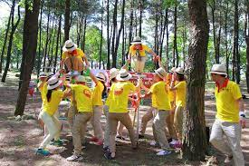

**Unity and Harmony**

Number of players: 6 players per team.

Location/terrain: A wide beach or an open field.

How to play: The 6 members of each team hold onto the handles of a long rope and clamp the rope between their legs. When the signal is given, everyone coordinates harmoniously to step evenly from the starting line until the last person crosses the finish line. At the finish line, 5 team members stay while one member carries the rope back to the next team, and the carrier is considered not yet finished.

During the game, if the rope touches the ground or if any member falls, the team must go back to the starting line. After 5 minutes, the team that achieves the most progress will score the highest points and win.

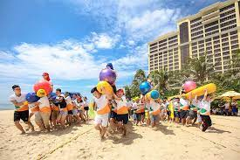

**The Endless Journey**

Number of players: Each team consists of 11 players, and there must be a minimum of 2 teams.

Location/terrain: Played in a wide and flat field.

How to play:

Each team selects 5 members to stand at the finish line, whose task is to transport equipment back to the starting line. Each round of movement involves 6 members, who construct a makeshift vehicle by placing a board on top of a barrel to form a cart. Two members hold sticks in the middle, two in the front, and two in the back lift the barrel. When the signal to start is given, the 6 members move together on the barrel cart from the finish line to the starting line.

At the starting line, 6 members remain, and the next group of 5 quickly brings the equipment back for the next 6 members to begin. During the game, if a member falls or if the cart breaks down, they must stop and wait for that member to climb back on before continuing. After 10 minutes, members who reach the finish line will be awarded 100 points each.

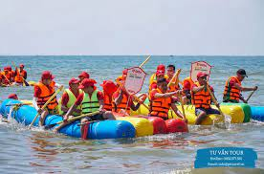

**High-Speed Wheel**

Number of players: Each team needs at least 6 players, and there are 2 teams.

Location/terrain: Played on a wide field or on the sandy beach.

How to play: In the game, 4 team members stand inside a 2-meter wheel made of foam floats. The team leader directs, while the members inside the wheel push together to move from the starting point to the finish line. Two members outside push the wheel towards the finish line and receive other players in the wheel for the next turn. Within 10 minutes, the team that brings the most players to the finish line will be the winning team.

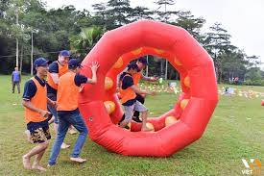

**Overcoming Obstacles**

Number of players: Each team needs at least 3 players, and there are 2 teams.

Location/terrain: Played outdoors with many obstacles set up.

How to play: Each member of the team works together to overcome multiple consecutive obstacles to bring the flag back to the starting point. Within a specified time frame, the team that retrieves the most flags will earn the highest score and win the game.

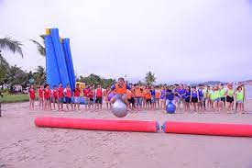

**Team Strength**

Number of players: Each team needs at least 2 pairs of male and female players.

Location/terrain: On a wide grass field.

How to play: Two members, one male and one female, flip a tire from the starting line to the finish line. The remaining members stay behind to use a rope to pull the tire back, and then the next pair of two members moves, and so on until all members have participated. Within the shortest time frame, the team that moves the tire with the most members across the finish line earns the highest score.

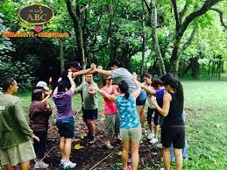

**Mysterious Maze**

Number of players: Minimum of 2 teams, with each team consisting of 3 players.

Location/terrain: This outdoor team building game will be played on the beach or in a grassy area.

How to play: Teams assemble and line up in a straight line along the path of floating balls, with one member at each position. When signaled by the game leader, players quickly jump onto the floating balls to reach the other side and retrieve an item to bring back. During the game, any player who touches the ground or falls must start again from the beginning. After a predetermined period of time, such as 5 or 10 minutes, the team that retrieves the most meaningful items will win the game.

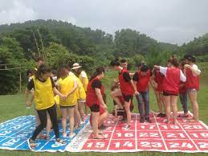

**Battle Royale**

Number of players: Each team consists of at least 1 male and 1 female player, with a minimum of 2 teams.

Location/terrain: The game can be played on a soccer field or a wide open field.

How to play: Each team selects 2 members, one male and one female, equipped with helmets and holding a stick to participate in 2 rounds of matches. When signaled by the game leader, players use their sticks to push their opponents out of the designated playing area, marked beforehand. Players are only allowed to push horizontally with the stick and are strictly prohibited from using their feet during the game. The team whose member remains in the playing area at the end wins the game.

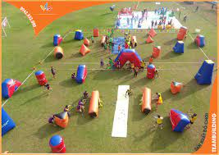

**Unity and Strength**

Number of players: Minimum of 2 teams, each team with 8 players.

Location/terrain: Played on a sandy beach or a wide recreational field.

How to play: Each team consists of 8 members, with each player holding a corner of a large blanket. The objective for each player is to use the blanket to toss a ball from the starting line to the finish line and into the basket. The team that successfully scores 10 balls in the basket first wins the game.

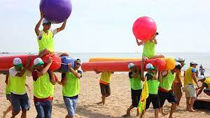

**Mighty Warriors**

Number of players: Each team consists of 2 members, and there should be at least 2 teams.

Location/terrain: Played on a grass field or a sandy surface.

How to play: Each team selects 2 members to participate, wearing jerseys with a ball-shaped design. The game consists of 3 rounds. When signaled by the game supervisor, team members use their strength to push the opposing team members out of bounds. The team that keeps their members inside the boundary for the longest duration wins the game.

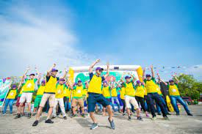

**United Goal**

Number of players: Each team consists of 10 members, and there should be at least 2 teams.

Location/terrain: Played on the sandy beach shore.

How to play: Each team designates one player to stand at the finish line to assist in retrieving the beach balls. During each move, there are 10 team members, with 9 of them carrying inflatable rafts on their shoulders, and the remaining member sitting on the raft holding a beach ball. When signaled by the game supervisor, players run from the starting point to the throwing position, preparing to throw the beach ball. Each player has 2 throwing attempts per move. If the first throw misses, they can try again with the second attempt.

If both throwing attempts miss, they still have to return to the starting point. The team that successfully throws 10 beach balls into the basket first will raise the program's message high and win the game.

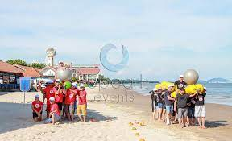

**Team Stride**

Number of players: At least 2 teams, with each team comprising 5 members.

Location/terrain: Best played on a sandy beach.

How to play: Each team consists of 5 members, with 4 members wearing turtle shells (or any similar protective gear) and 1 member wearing a helmet, sitting on top of the turtle shell. The members wearing turtle shells move to transport the member sitting on top, rolling the mat from the starting point to the finish line and returning to pick up the next members. Within a set and short timeframe, the team that moves the fastest earns the highest score.

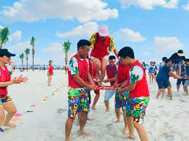

**Peak Conquest**

Number of players: At least 2 teams, with each team comprising at least 3 members to increase excitement.

Location/terrain: A spacious grass field equipped with a wall.

How to play: Each participating team member will be blindfolded. The task for each member is to navigate through a path filled with obstacles. The organizers have strategically placed bombs along the path. If a member touches a bomb, they must return to the starting point and begin again. After a set time, the team with the most members who successfully navigate the path wins.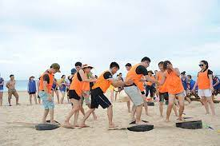

**The Path to Success**

Number of players: Requires at least 2 teams, with each team consisting of more than 2 players.

Location/terrain: On grassy or sandy terrain.

How to play: Each participant must be blindfolded. The objective of the game is to navigate through a challenging path (made of air). Organizers will place "bombs" along the path. Any team member who steps on a "bomb" must start over from the beginning. After a set period, the team with the most members successfully traversing the path wins.

Meaning of the game: This game simulates the journey of individuals in life, where they must overcome various difficulties and challenges before achieving success.

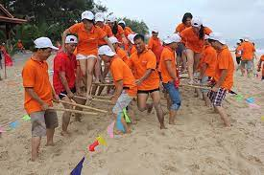

**Symphony Orchestra**

• Number of participants: Unlimited

• How to play:

The whole group will be divided into playing teams. Each team is assigned to shout "Tùng", "Xẻng", "Cắc" (representing different instruments) when signaled by the facilitator.

The team that shouts the loudest will be the winning team. Teams that shout slowly, quietly, or incorrectly will be penalized. This simple team-building game is highly valuable in promoting and inspiring further activities in the team-building session.

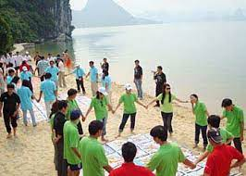

**Talented Captain**

• Equipment: Microphone, speaker, podium, etc.

• How to play:

The facilitator organizes the participants to stand in rows. Then, the game starts with the captain-style greeting by raising one hand. When the command is given:

"Wave hits starboard" - move one step to the right

"Wave hits port" - move one step to the left

"Water flooding the ship" - sit down

Anyone who makes a mistake or moves slowly will be eliminated from the line and will face consequences after the game.

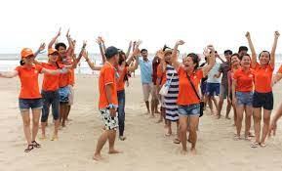

**"Trust the Captain"**

• Terrain: Mountainous terrain with rough terrain and many obstacles.

• Number of players: Depending on the organizers.

• Equipment used: Blindfolds equivalent to the number of participants, objects used as obstacles.

• How to play:

Each team lines up like a train. The captain leads at the front. Except for the captain, all other members are blindfolded, with the person behind placing their hand on the shoulder of the person in front and following the captain's lead.

During the journey to the finish line, utilize the terrain or set up some obstacles to challenge the teams. The "trains" move, and the captain has the sole authority to command: turn left, right, up, down, etc. The team that reaches the finish line first wins.

• Rules: Any train that touches an obstacle must either return to the beginning or be penalized with additional time depending on the terrain and difficulty of the game.

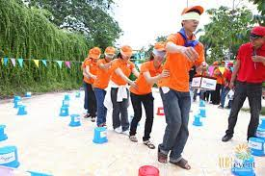

**"Who Understands Who Best"**

• Number of players: Unlimited, depending on the organizers.

• Equipment used: Papers containing keywords to be described.

• How to play:

Teams stand in rows horizontally, and each team sends one person to meet the MC to receive a paper containing a keyword. Then they return to stand apart from other team members at a distance of 1.5 - 2 meters and convey the content on the paper through gestures, movements, and body language. The team that correctly answers the content on the paper wins.

• Rules: The person conveying the keyword is not allowed to speak. If they speak, their team will be penalized with extra time.

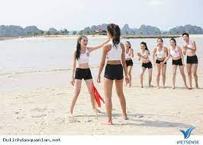

**"Find the Right House"**

• Number of players: Unlimited participants.

• Equipment used: Colored pens and cardboard cut into different shapes to make house numbers. Additionally, prepare ribbons, balloons, tapes, or related items.

• How to play:

Allow participants to observe for 2-3 minutes, depending on the program's rules. Then, they must move away about 3-4 meters, depending on the outdoor team-building space. Blindfold the players and wait for the signal from the program leader. When the whistle blows, they must locate the shapes, examine them carefully, and then announce the number on the shape. If they correctly identify the house number, they win.

• Rules: If they guess incorrectly, they will be penalized after the game ends.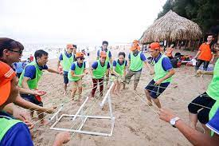

**"Capture the Flag"**

• Equipment used: 10 flags.

• How to play:

Players are divided into two teams, each standing on one side. Behind each team, there are 5 flags arranged horizontally. You must run past the enemy's defensive line to the flag area to capture the enemy's flag.

If you get tagged while chasing, you become a prisoner. However, if you manage to reach the flag area, you can choose to take a flag back or release all prisoners from your team. The team that brings back all 10 flags wins.

• Rules: Players must not run before the signal from the program leader.

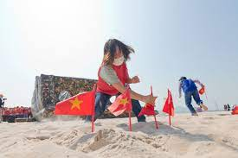

**"Finding Paper in the Night"**

• Time: Nighttime

• Number of players: 10-40 people

• Equipment used: Many small pieces of glowing paper

• How to play:

The program organizers scatter small pieces of glowing paper along the path, which can be on tree branches, beside the road, or on the ground...

All players are required to run as fast as they can from the starting point to the finish line. While moving, you must also count the number of pieces of paper on both sides of the road. Upon reaching the finish line, the MC will score you in two parts: one point for the running time and one point based on the number of pieces of paper you counted along the way.

Regarding speed points, the runner who takes the longest time will receive no points, while the others will receive points based on how many people they outrun.

Regarding accuracy points, you receive one point for each piece of paper you accurately count. If you miscount by 1 piece, you will lose 2 points.

• Rules: While running, you must not disturb the pieces of paper along the roadside.

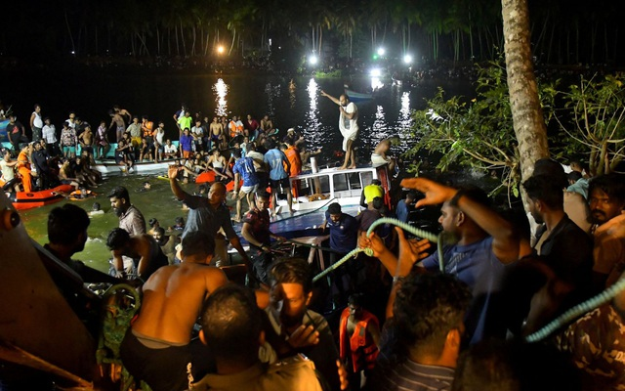

"Solid Link"

• Terrain: Choose a wide, flat playground area.

• Number of players: Unlimited participants

• Equipment used: Any object can be chosen as the playing tool, such as a branch, a flower stem, a brick, etc.

• How to play:

All members are divided into two groups sitting 10-15m apart from each other in a horizontal line, with the playing object placed in the middle, such as a tree branch, a flag, a cloth, etc. When the program leader gives the signal, members of each team must link arms together and hop like frogs towards the playing object. The team that reaches the object and holds it up first wins the game.

• Rules: If any team's link is broken, they must stop, return to their original position, and start again.

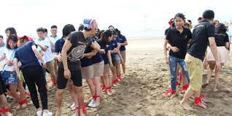

**"Elephant's Head, Mouse's Tail"**

• Number of players: Unlimited

• Equipment used: Pen and paper equivalent to the number of participants

• How to play:

Members of each team will line up vertically and stand about 1 meter apart to avoid exchanging information. The program organizer will give the first person of each team a piece of paper containing a keyword and ask this person to draw an image that accurately represents the word on the paper. Then, the first person will pass the paper with their drawing to the second person, who will replicate the drawing and pass it to the third person, and so on until it reaches the last person in the team.

The last person will use the images on the paper from the person above to find the correct answer in the provided bulletin.

The team that is the fastest and provides the correct answer according to the bulletin will win.

• Rules: No exchanging of information related to the answer verbally, and no using words in the drawing, only images. If words are used, the result of that team will not be accepted.

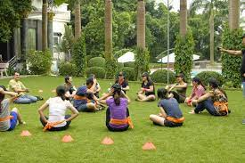

**"The Silk Ribbon"**

• Number of players: Unlimited

• Equipment used: No equipment required

• How to play:

Teams line up vertically. When signaled by the program leader, team members quickly lie down, connecting one after another to form the longest silk ribbon for their team. Players can use various movements or positions to make their line as long as possible, and they can also use their clothes and personal belongings to extend the "silk ribbon." After completing the task, the facilitator will measure and determine which team has formed the longest line, and that team will win.

